1. The website exists to display the world of Erilia, a homebrew campaign setting for dungeons and dragons, a fantasy tabletop roleplaying game. As opposed to most campaign settings for the game, which are usually set in fantasy medieval worlds, Erilia is set in the near future era with fantasy elements (monsters, different planes of existence, and magic).
2. The target demographic of the website are experienced players and game masters either looking for a different feel for a campaign or wanting to explore the idea of a more modern setting. This means that most visitors would already be “in the loop” and not require too much introduction, however some will not, and therefore a basic explanation of the game will be presented. Age range of target audience is 16 – 40, with some expected outliers. To this extent, the website should not have any form of graphic content.
3. The website will consist of 3 pages: The **home** page, the **nations** page, and the **newsletter** page. All the webpages will have a sticky horizontal navigation bar at the top, with buttons leading to the other webpages, and a sticky vertical navigation bar on the right side, leading to separate paragraphs on each webpage.   
   1. The **home** page consists of basic information about the game and the setting, also working to entice visitors. The page is structured into paragraphs with a ‘two-line tall’ header, as each paragraph is on the same level of importance.
   2. The **nations** page contains more detailed information about Erilia, specifically about the various continents and nations of the setting. An interactive map and the page navigation bar function to navigate the information.
   3. The **newsletter** page – sign up with email and choice of information categories the user is interested in.
4. The most important aspect of the website is ease of accessing and navigating information and its readability. To this extent, the information on home page is clearly structured, and the map on nations page provides visual feedback with the information provided.
5. The webpages consist of a background image over the entire window, and a central column with a semi-transparent background colour. There is also a couple more images throughout the content where appropriate. The colour pallet consists of the background and navigation bar text (main colour), the text and page navigation bar (contrast), and the site navigation bar and headers (detail). The map is constructed from many independent parts, each coloured in order to separate the interactive parts and highlight content.
6. The colours were chosen based on the background. The choice to make home page blue was to 1. bring attention to the ‘high-tech’ aspect of the world and 2. to separate from the official D&D red colour scheme. The map images were cut out from a screenshot of the Erilia map, generated by Azgaar’s fantasy map generator (<https://azgaar.github.io/Fantasy-Map-Generator/>) using GIMP. The nation images are downloaded from imgur in order to appease CORS policy.

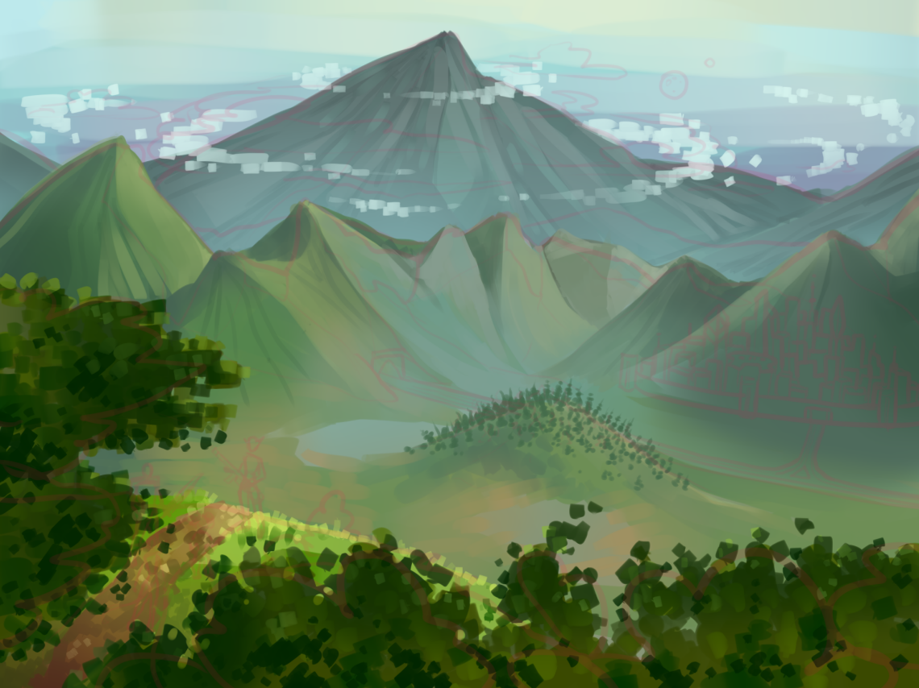Common background image, commissioned from my sister (@x_ajas_x on ig)

added onto the background with photopea (image available at <https://www.svgheart.com/product/dragon-fantasy-animal-free-svg-file/>)

Art generated by <https://hotpot.ai/art-generator>,   
modified using photopea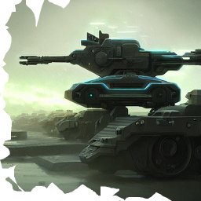

1. User testing came back with mostly positive results. The map was universally appreciated, but also criticized for it’s god-awful execution on multiple instances.
2. The form still does nothing, the content amount increased but not astronomically so, and the map drawing is extremely inefficient, taking up to multiple seconds to finish.